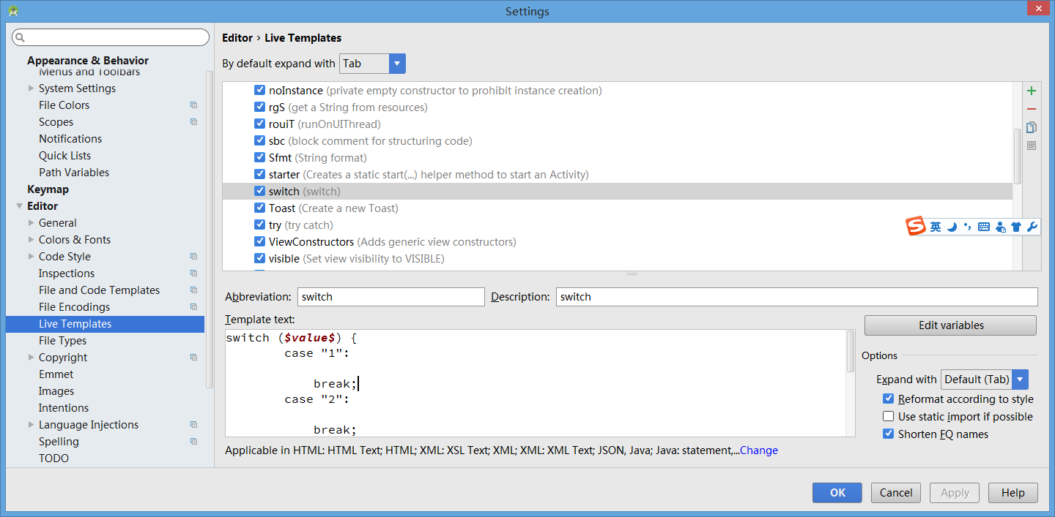
http://blog.csdn.net/DesmondJ/article/details/47017205

switch ($value$) {
case "1":

break;
case "2":

break;

default:

break;
}

android.widget.Toast.makeText($className$.this, "$text$", Toast.LENGTH_SHORT).show();

